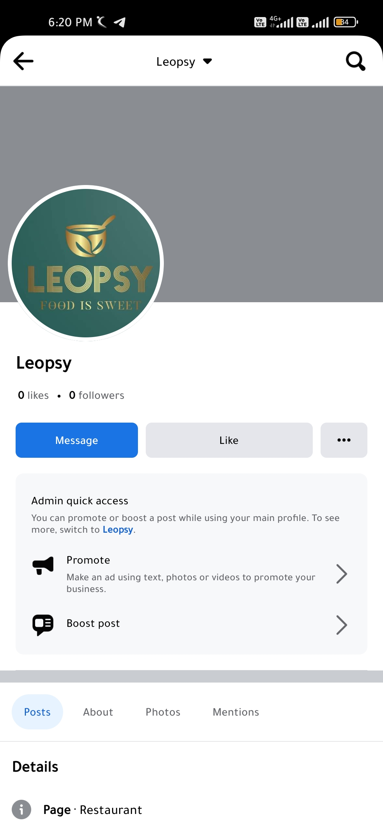**ASSIGNMENT-2**

Create a New Facebook Business Page and Post one social media poster for your brand.

|  |  |
| --- | --- |
| NAME | Deepak.M |
| NM ID | 9DFDF985C4FC711933E4B6077834F86E |
| ASSIGNMENT 2 | Create a New Facebook Business Page and Post one social media poster for your brand |

